Dr.M. Nedwidek-Moore/Stuyvesant HS Jonathan Quang

Assignment #10/ Due 5/3/16 SBS11QHG Period 10

Opening Declaration: I promise to do this assignment authentically

Student Signature: ________________________ Date:_________

FAP - Familial adenomatous polyposis  
WNT stands for wingless integrated pathway. The pathway involves regulation of gene expression. When off, the related genes are not expressed.  
LRP - Low density lipoprotein receptor-related protein  
APC - Adenomatous polyposis coli  
GSK3 - Glycogen synthase kinase-3  
CKI - Cyclin-Dependent kinase inhibitor  
P - Phosphate group  
Ub - Ubiquitin  
βTrCP - beta-transducin repeat protein  
TCF - Transcription factors  
Dvl - a family of cytoplasmic phosphoproteins called disheveled.   
ICAT - Isotope coded affinity tag that can be used to tag proteins or in this case, block certain protein binding sites. This has been discovered in mice to block the binding site between beta catenin and TCF

Works Cited

1. Schultz, Nora. "Nanocarriers Come Through." *MIT Technology Review*. MIT Technology Review, 6 Jan. 2011. Web. 03 Apr. 2016. <https://www.technologyreview.com/s/422297/nanocarriers-come- through/>.

2. Domingue, Melanies J., Florian Rambow, Bastien Job, Laura Popon, Wanguo Liu, Lionel Larue, and Jacky Bonaventure. "ICAT, Inhibitor of β- catenin and TCF4, a New Modulator of Melanoma Cells Motility and Invasiveness." *Cancer Research*. Journal of Cancer Research, 10 Feb. 2014. Web. 03 Apr. 2016. <http://cancerres.aacrjournals.org/content/early/2014/02/08/0008-5472.CAN-13- 0920.full.pdf+html>.

3. Rajpurohit, H., P. Sharma, S. Sharma, and A. Bhandari. "Polymers for Colon Targeted Drug Delivery." *Indian Journal of Pharmaceutical Sciences*. Medknow Publications, Nov.-Dec. 2010. Web. 03 Apr. 2016. <http://www.ncbi.nlm.nih.gov/pmc/articles/PMC3178968/>.

Closing Declaration: At the close of this assignment, I can attest to having done it by my own hand. If I received help from peers or from tutors in doing it, this was purely to understand the material, and I did not knowingly transfer the information from or to other sources (my peers or otherwise) in the process of doing this work

Student Signature: ________________________ Date:_________

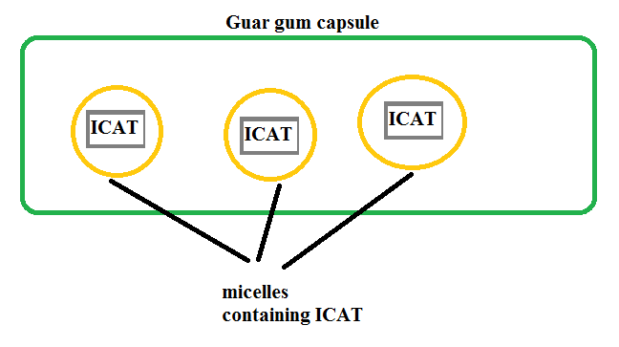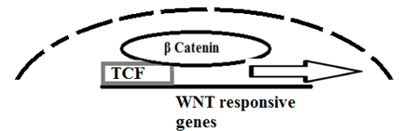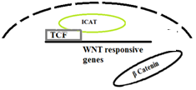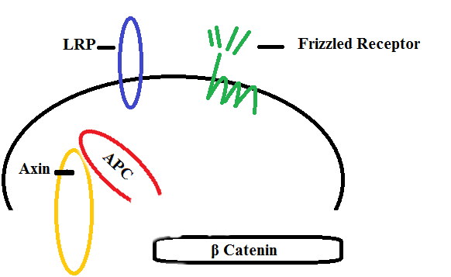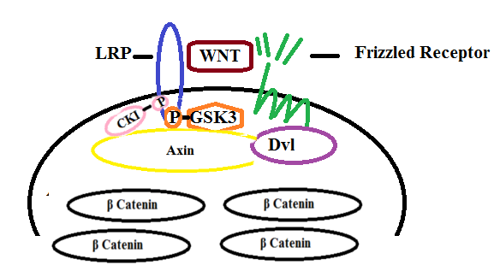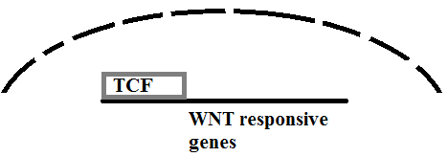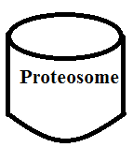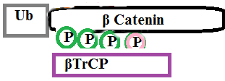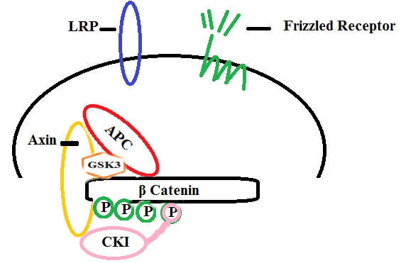

The proposed cure is to fill small soapy clusters of molecules, called micelles, to carry drugs into cells and release ICAT into the cells nucleus due to a change in pH in the nucleus [1]. ICAT will prevent β-catenin from bonding to TCF[2]. This method is just as effective in cancer cells as well. These micelles will be encased in a capsule of guar gum. A study has shown that guar gum does not degrade until it reaches the colon where bacteria degrade the capsule, allowing for the slow release of the encased drug [3].

Released ICAT bonds with TCF.

Micelles break up in the nucleus

Cells will intake micelles.

Guar gum will be broken down by bacteria in the colon.

The APC protein becomes too short to form the destruction complex when the WNT pathway is off, do beta catenin bonds with TCF and WNT genes are transcribed.

FAP is caused by nonsense or frame shift mutations on chromosome 5, and it affects epithelial tissue.

Familial Adenomatous Polyposis

β-Catenin moves to the nucleus to bind with TCF, which begins transcribing genes.

Normal WNT Pathway  
When On

β-Catenin is targeted for destruction by a proteosome and TCF is never activated.

Normal WNT Pathway  
When Off  
Solid curved lines are cellular membrane. Dotted curved lines are nuclear membranes.